Lab2 và Lab 3
Lab2: CÁCH SỬ DỤNG API
B1: Cài SDK Gemini: pip install google-genai
B2: Cài đặt thư viện python-dotenv: tự động hóa việc nạp API Key mà Code vẫn sạch và an toàn.
B3: Lấy và tạo API key Gemini: https://aistudio.google.com/app/apikey
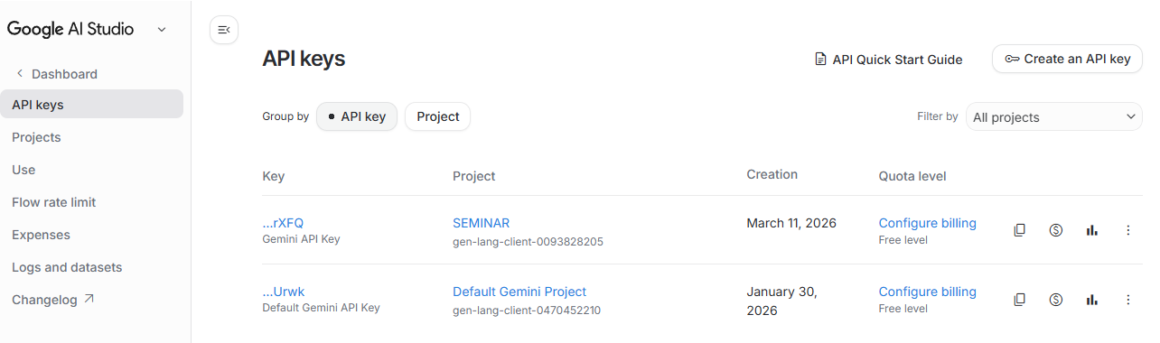
Lab2
Lab21
Code:
import os
from dotenv import load_dotenv
from google import genai

# Hàm này sẽ tự động tìm file .env trong thư mục và nạp các biến vào hệ thống
load_dotenv()

if __name__ == "__main__":
# Khởi tạo client.
# Nhờ có load_dotenv() ở trên, Client sẽ tự động thấy được GEMINI_API_KEY
client = genai.Client()

response = client.models.generate_content(
model="gemini-2.5-flash",
contents="What is the FizzBuzz problem?"
)

print(response.text)

Result:
“
The **FizzBuzz problem** is a classic programming interview question, often used as a sanity check to filter out candidates who cannot program at all. It's a surprisingly effective way to quickly assess a candidate's understanding of basic programming constructs.

Here's the problem statement:

---

**The FizzBuzz Problem**

Write a program that prints numbers from 1 to 100. But for multiples of three print "Fizz" instead of the number and for the multiples of five print "Buzz". For numbers which are multiples of both three and five print "FizzBuzz".

---

Let's break down the rules more concretely:

1. **Loop** or iterate through numbers, usually from 1 to 100 (or up to a given number N).
2. If the number is a multiple of **both 3 and 5** (i.e., a multiple of 15), print "FizzBuzz".
3. Else if the number is a multiple of **3**, print "Fizz".
4. Else if the number is a multiple of **5**, print "Buzz".
5. Else (if none of the above conditions are met), print the number itself.

**Example Output (for numbers 1 to 15):**

1
2
Fizz
4
Buzz
Fizz
7
8
Fizz
Buzz
11
Fizz
13
14
FizzBuzz

**Why is it used?**

While it seems incredibly simple, FizzBuzz is used for several reasons:

* **Sanity Check:** It quickly identifies candidates who cannot write even the most basic Code. You'd be surprised how many experienced-sounding candidates fail it.
* **Tests Fundamental Concepts:** It requires a basic understanding of:
* **Loops:** To iterate through a sequence of numbers.
* **Conditional Statements:** `if`, `else if`, `else` to check different conditions.
* **Modulo Operator (`%`):** To check for divisibility (e.g., `number % 3 == 0`).
* **Logical Thinking:** The order of the conditions is important (checking for "FizzBuzz" first prevents a number like 15 from just printing "Fizz" or "Buzz").
* **Language Familiarity:** It shows whether a candidate is familiar with the syntax for these basic constructs in their chosen programming language.

In essence, FizzBuzz isn't meant to be a challenging problem, but rather a low-bar filter to ensure a candidate possesses foundational programming knowledge.
”

Lab22
Code:
import os
from dotenv import load_dotenv
from google import genai
from google.genai import types

# Tự động tìm và nạp các biến từ file .env vào hệ thống
load_dotenv()

if __name__ == "__main__":
# Bây giờ Client() sẽ tự động thấy GEMINI_API_KEY
client = genai.Client()

response = client.models.generate_content(
model="gemini-2.5-flash",
contents="What is the Two Sum problem?",
config=types.GenerateContentConfig(
system_instruction="You are a hiring manager at a tech company.",
temperature=0.2,
max_output_tokens=100,
candidate_count=1
)
)

completion_tokens = response.usage_metadata.candidates_token_count

print("Completion Tokens: ", completion_tokens)
print("Output: ", response.text)

Result:
“
Completion Tokens: 2
Output: Ah,
”
Lab23
Code:
import re
import os
from dotenv import load_dotenv
from google import genai
from google.genai import types

USER_PROMPT = """
def print_fibonacci_sequence(n: int) -> None:
"""
SYSTEM_PROMPT = ("You will be provided with a Python function signature. Your task is to implement the function. Return "
"Code only.")

def get_Code_with_instructions(Code: str) -> str:
"""
Add a comment to the Code for specific Code completion instruction
:param Code: Python Code as string
:return: The Code with additional instruction - "Complete this Code"
"""

return Code + "\n# Complete this Code"

if __name__ == "__main__":
# Tự động nạp biến môi trường từ file .env
load_dotenv()

# Khởi tạo client, tự động đọc GEMINI_API_KEY
client = genai.Client()

response = client.models.generate_content(
model="gemini-2.5-flash",
contents=get_Code_with_instructions(USER_PROMPT),
config=types.GenerateContentConfig(
# Đưa các vai trò system vào một mảng (list)
system_instruction=[SYSTEM_PROMPT, "Include docstring and typehints."],
temperature=1.0,
candidate_count=2 # Tương đương với thông số n=2 của OpenAI
)
)

# Lặp qua danh sách các kết quả trả về (candidates) thay vì choices
for i, candidate in enumerate(response.candidates):
# Truy cập vào nội dung text của từng candidate
output = candidate.content.parts[0].text

# Sử dụng biểu thức chính quy (regex) y hệt như logic cũ của bạn để bóc tách Code
Code_suggestion = re.sub(r"(.*?)```python(.*?)```(.*)", r"\2", output, flags=re.DOTALL).strip()

print(f"Output {i + 1}:")
print(Code_suggestion)
print("-" * 50) # Thêm dòng gạch ngang cho dễ nhìn giữa 2 output

Result:
“
Output 1:
def print_fibonacci_sequence(n: int) -> None:
"""
Prints the first n numbers of the Fibonacci sequence.

The Fibonacci sequence starts with 0 and 1. Each subsequent number
is the sum of the two preceding ones (e.g., 0, 1, 1, 2, 3, 5, ...).

Args:
n: The number of Fibonacci numbers to print.
If n is less than or equal to 0, nothing is printed.
"""
if n <= 0:
return
elif n == 1:
print(0)
return

# Initialize the first two Fibonacci numbers
a, b = 0, 1
fib_sequence = [a, b]

# Generate the remaining n-2 Fibonacci numbers
for _ in range(2, n):
next_fib = a + b
fib_sequence.append(next_fib)
a = b
b = next_fib

# Print the sequence elements separated by spaces
print(*fib_sequence)
--------------------------------------------------
Output 2:
def print_fibonacci_sequence(n: int) -> None:
"""
Prints the first n numbers of the Fibonacci sequence.

The Fibonacci sequence starts with 0 and 1, and each subsequent number
is the sum of the two preceding ones (e.g., 0, 1, 1, 2, 3, 5, ...).

If n is 0 or less, nothing is printed.

Args:
n (int): The number of Fibonacci numbers to print.
"""
if n <= 0:
return

# Initialize the first two Fibonacci numbers
a, b = 0, 1
fib_sequence = []

# Generate the Fibonacci sequence
for _ in range(n):
fib_sequence.append(a)
a, b = b, a + b # Update a and b for the next iteration

# Print the generated sequence, separated by commas
print(", ".join(map(str, fib_sequence)))
--------------------------------------------------
”
Lab3: HỎI ĐÁP VỚI AI
Lab31
Prompt:
“Explain the geometric mean.”
Code:
“
def get_geometric_mean_of_two_numbers(a: float, b: float) -> float:
return pow(a * b, 1 / 2)
num1: float = 5.0
num2: float = 20.0

print(get_geometric_mean_of_two_numbers(num1, num2))
”
Result:
“
10.0
”
Lab32
Prompt:
“Write a Python function to calculate the geometric mean of a list of numbers.”
Code:
“
def get_geometric_mean(*nums):
if not nums:
raise ValueError("At least one number is required")
for num in nums:
if not isinstance(num, (int, float)):
raise TypeError("All numbers must be integers or floats")
product = 1
for num in nums:
product *= num
return pow(product, 1 / len(nums))
”
Lab33
Prompt:
“
Write a robust Python function to calculate the geometric mean of a sequence of numbers.
The function should:
- accept a variable number of arguments
- raise an error if the sequence is empty
- handle invalid inputs
- use Python's reduce function
”
Code:
“
from functools import reduce

def get_geometric_mean_for_three_numbers(a, b, c):
return (a*b*c)**(1/2)

def get_geometric_mean(*nums: float) -> float:
"""
Get the geometric mean of a sequence of numbers
"""

if not len(nums):
raise ValueError("Cannot calculate the geometric mean of an empty sequence")

product = reduce(lambda a, b: a * b, nums)
if product < 0 and len(nums) % 2 == 0:
raise ValueError("Cannot calculate the geometric mean")

return pow(product, 1 / len(nums))

”

